**Angat Nayanbhai Shah | Div - C**

**Compiler Craft – A Compiler Design Application**

## **Project Description**

Compiler Craft is a Flutter-based mobile application that simulates compiler design concepts and demonstrates various phases of compilation. The app allows users to input expressions and view how they are processed through different compilation stages.

### **Key Features**

* **Expression to Compiler Phases** (Lexical Analysis, Parsing, AST, Code Generation)
* **Grammar Ambiguity Check & LL(1) Parser**
* **Full Compilation Process Simulation**, including :

1. Lexical Analysis – Tokenization of input.
2. Syntax Analysis – Generating an Abstract Syntax Tree (AST).
3. Semantic Analysis – Type checking and conversion.
4. Intermediate Code Generation – Three-Address Code (TAC).
5. Code Optimization – Optimized TAC.
6. Code Generation – Machine code representation.

The app provides a **step-by-step visualization** of each phase, making it easier for students and developers to understand compiler internals.

**Output**

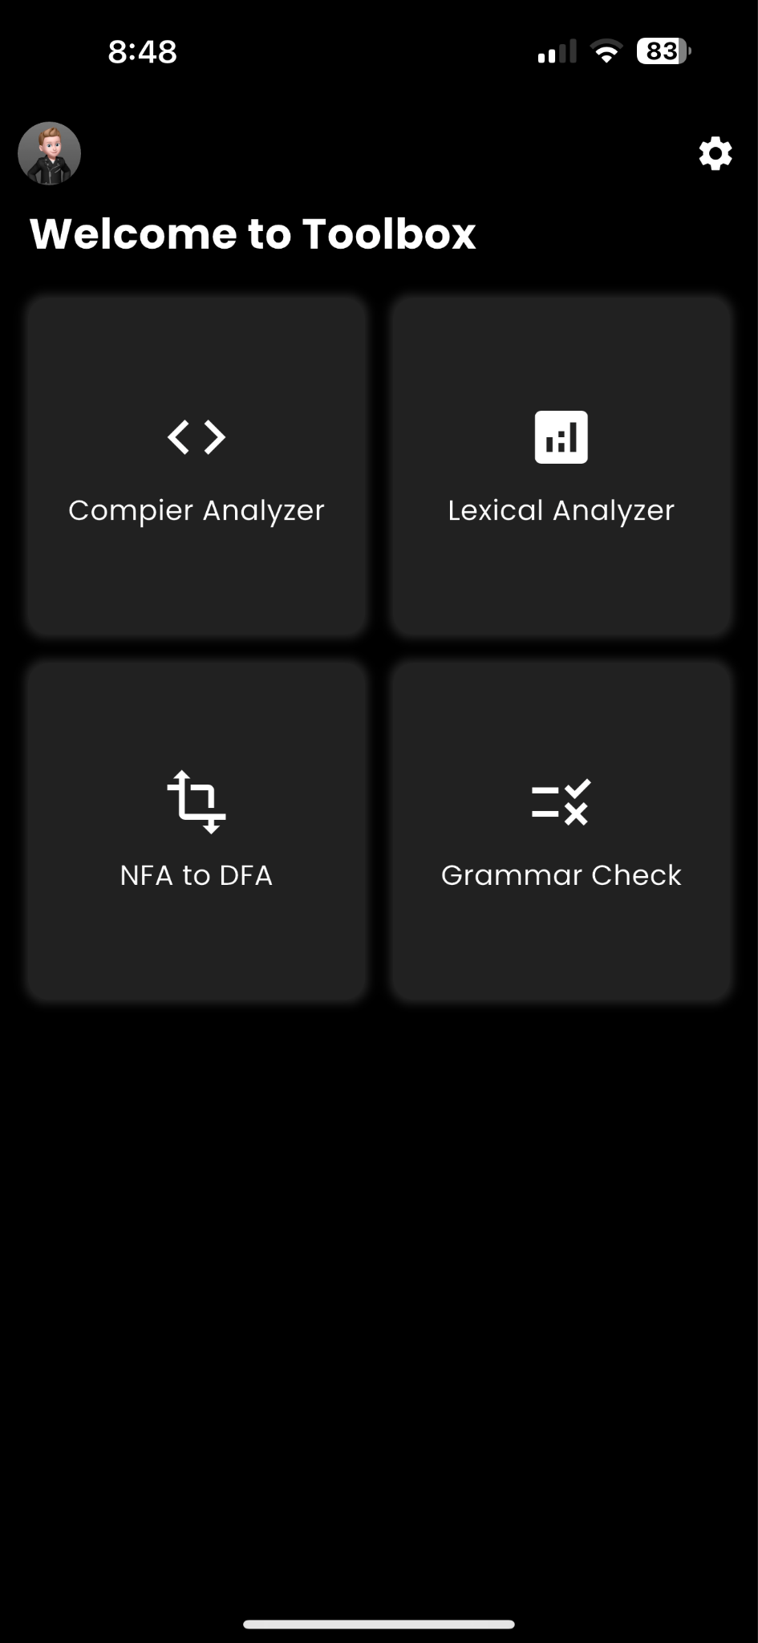 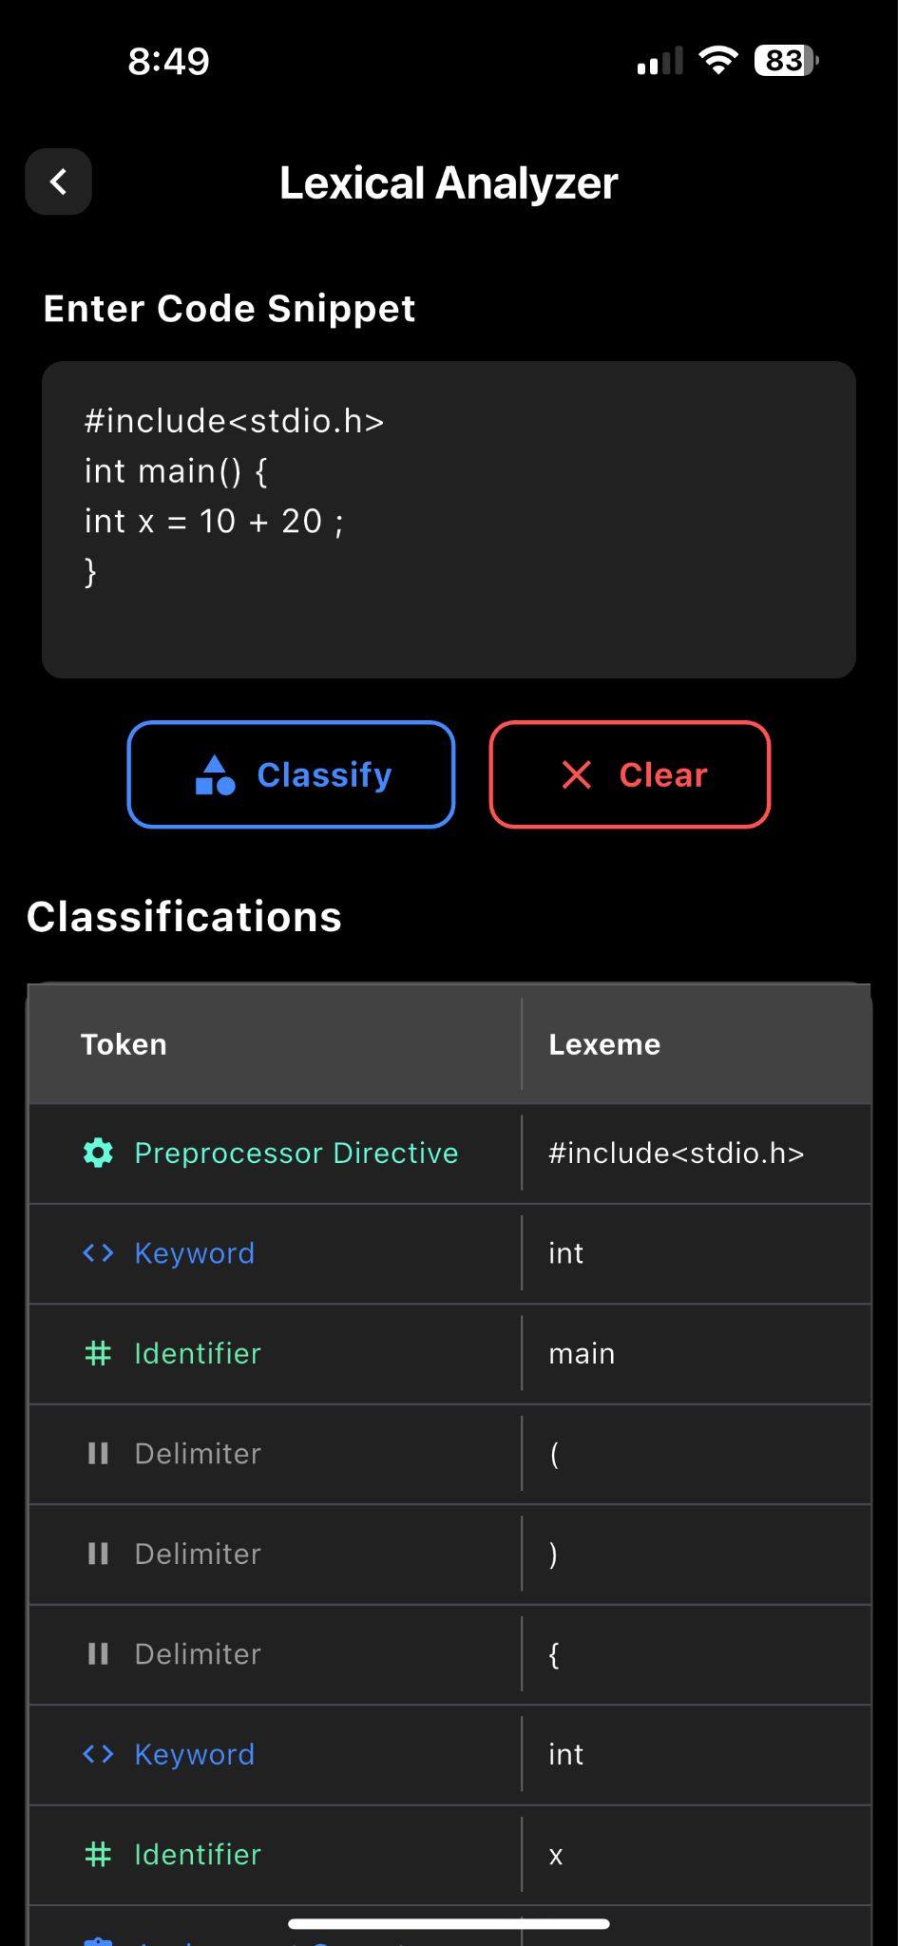 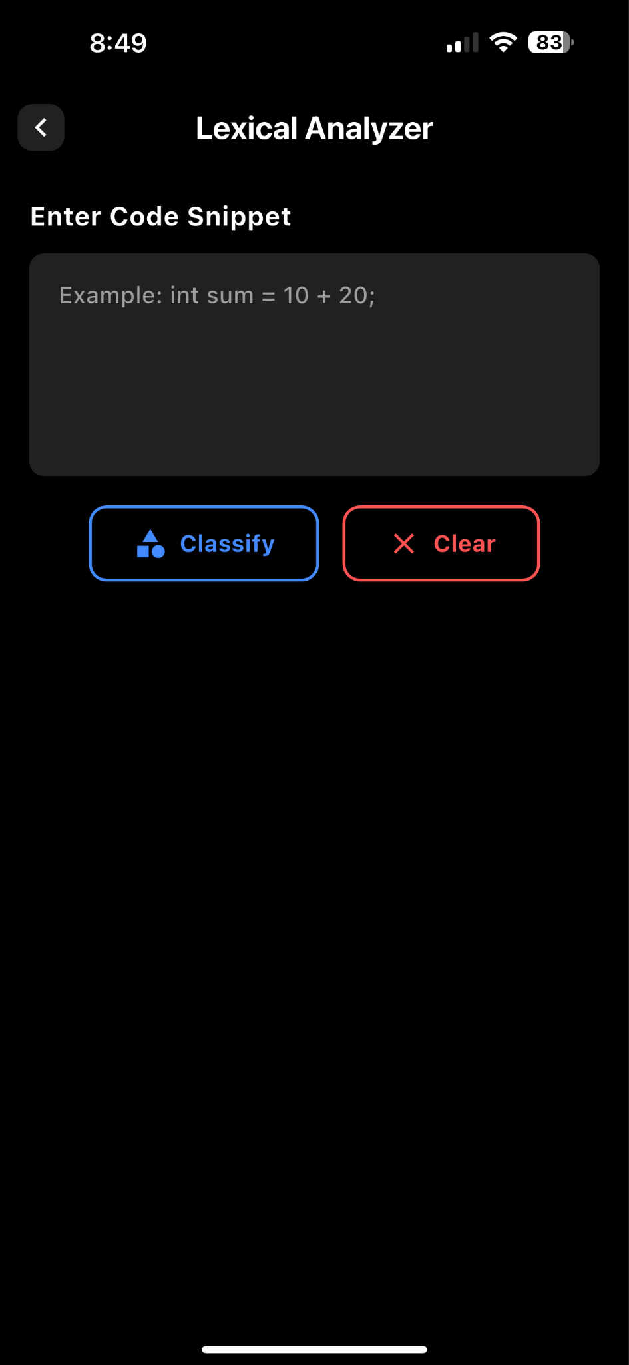

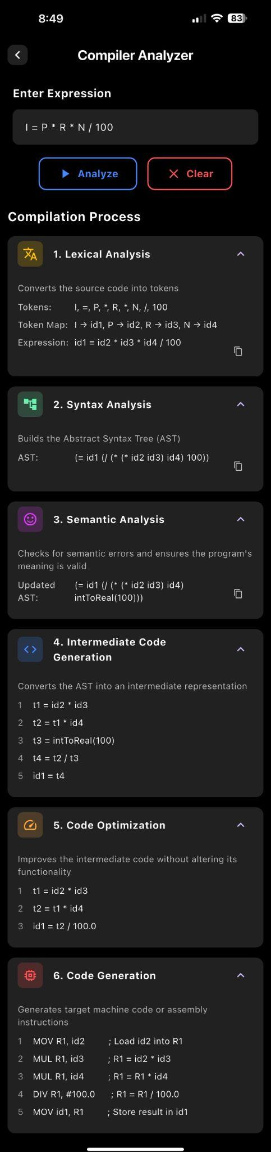 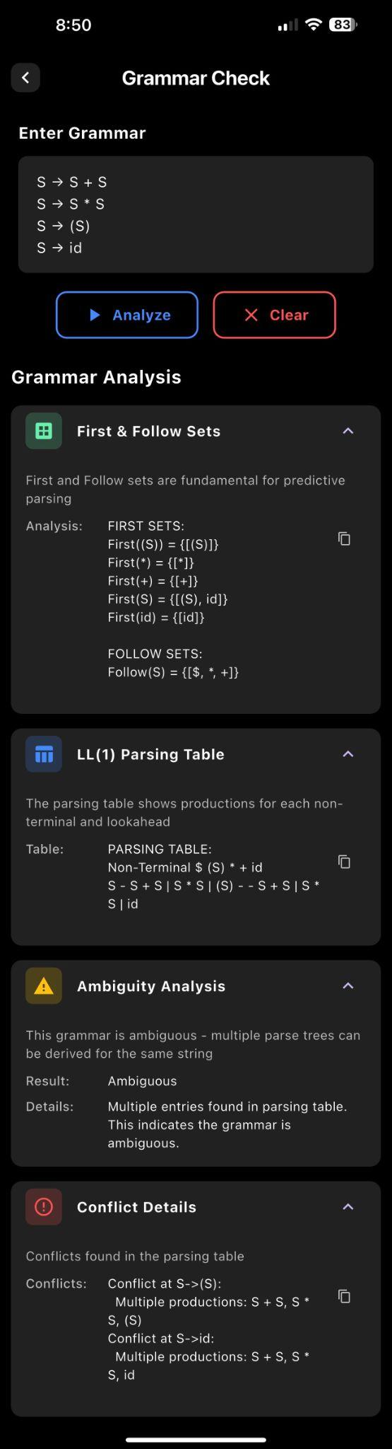

**Future Work**

* Regex to DFA : Implement the feature to process the expression from Regex to NFA to DFA.
* Improve UI/UX : Enhance the app's visual design for better usability.
* Add Detailed Explanations : Provide descriptions for each compilation phase.
* Optimize Performance : Ensure faster processing and display of results.
* Add More Compiler Features : Implement additional algorithms for grammar and other concepts of Compiler Design.